Lab 6 Submission by Siva Sudhakar Maddila

Screen shots:

Login Page:

2) Page after Login

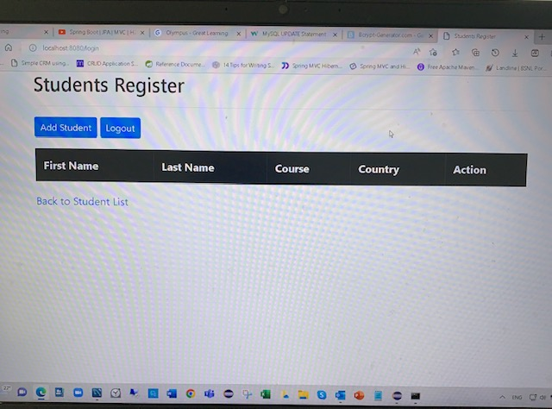

3) Page for adding new Students

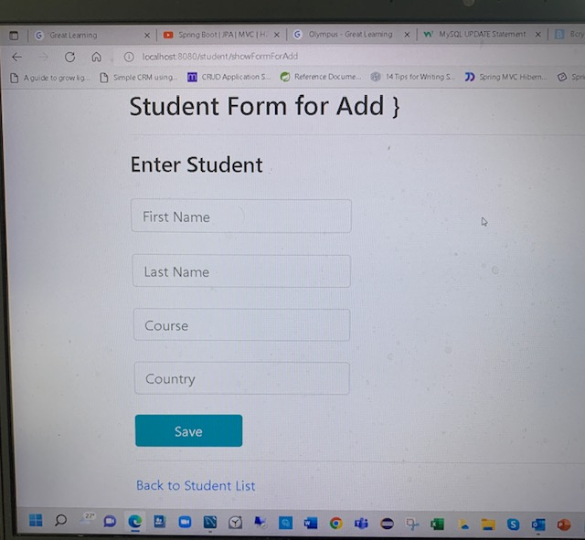

4) Student List Page with clickable Action Buttons

5) Delete Confirmation prompt

